PRAGUI – Quick tutorial

PRAGUI (Pipeline for RNAseq Analysis with GUI) is a python3 pipelining tool which allows the processing of fastq files containing read sequences from an RNA-seq experiment in order to ultimately perform differential expression analysis.

PRAGUI makes use of several freely available softwares:

|  |  |  |
| --- | --- | --- |
| Software | Version (>=) | Role |
| TrimGalore! | Cutadapt >=1.14  0.4.4 | Quality and adapter trimming |
| FastQC | v0.11.5 | Quality assessment of trimmed reads |
| STAR | 2.5.3a_modified | Read alignment program allowing for non-contiguous genomic regions |
| HISAT2 | 2.0.0-beta | Read alignment program allowing for non-contiguous genomic regions |
| Salmon | 1.1.0 | Software tool for estimating transcript-level abundance from RNA-seq read data. |
| Samtools | 1.3.1 | Filtering of low quality reads (MAPQ below threshold) |
| HTSeq | 0.9.1 | Count number of reads per genomic region (e.g., per gene) |
| DESeq2 | R>=3.4.1  1.14.1 | Exploratory analysis to assess replicate quality.  Differential gene expression analysis. |
| Cufflinks | v2.2.1  cummeRbund >= 2.20.0 | De novo alignment to find novel transcripts.  Count number of reads per genomic region (e.g., per gene).  Exploratory analysis to assess replicate quality.  Differential gene expression analysis. |
| MultiQC | 1.5 | Modular tool to aggregates results from bioinformatics analyses across many samples into a single report. It currently supports 72 bioinformatics tools including FastQC, TrimGalore, Cutadapt, STAR and HTSeq-count. A complete list can be found at <https://multiqc.info/>. |

1) Input

PRAGUI needs to access fastq files, name them and also group them according to their biological condition (e.g., WT vs KO or Treated vs Untreated). To do so, PRAGUI requires a tab separated file (i.e. a samples file) such as:

samples read1 read2 condition

AX6130_1 /path/to/file/AX61301_r_1.fq.gz /path/to/file/AX61301_r_2.fq.gz AX6130

AX6130_2 /path/to/file/AX61302_r_1.fq.gz /path/to/file/AX61302_r_2.fq.gz AX6130

AX6186_1 /path/to/file/AX61861_r_1.fq.gz /path/to/file/AX61861_r_2.fq.gz AX6186

AX6186_2 /path/to/file/AX61862_r_1.fq.gz /path/to/file/AX61862_r_2.fq.gz AX6186

for paired-end data. Alternatively for single-end data:

samples read1 read2 condition

AX6130_1 /path/to/file/AX61301_r_1.fq.gz NA AX6130

AX6130_2 /path/to/file/AX61302_r_1.fq.gz NA AX6130

AX6186_1 /path/to/file/AX61861_r_1.fq.gz NA AX6186

AX6186_2 /path/to/file/AX61862_r_1.fq.gz NA AX6186

The samples file can be provided by the user or can be created through the GUI.

1-a) Create samples file through GUI



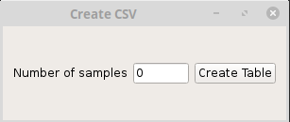

Specify number of samples and press the “Create Table” button.

A table appears that can be filled with the information necessary for creating a samples file.

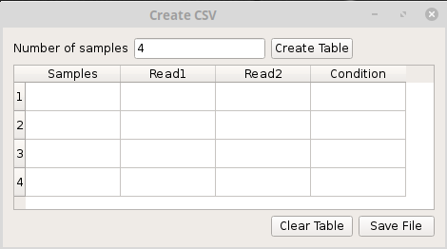

Paths for each fastq file are provided by pressing the corresponding cell. A new window appears to allow the selection of file location.

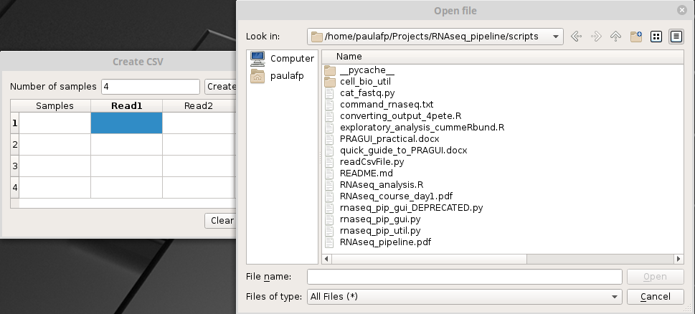

Once all sections have been filled, press “Save File” and close the window. Your samples file has been created.

**NOTE:** If your library is **single end**, please leave “read2” column empty.

1-b) Upload samples file to GUI

There is also the option to upload a samples file. Sometimes it might be easier to create a file using a text editor or to re-use a file that was generated by a previous run of PRAGUI.



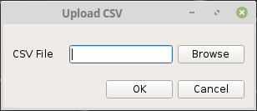

Use the “Browse” button to find your samples file and press “OK”.

1-c) Provide Genome Information



1-c.1) Species reference genome in Fasta format

The reference genome file (in fasta format) is required at the alignment step. It should be specified under the “Fasta File” entry. By clicking on the corresponding “Browse” button, the overall path for the fasta file can be found.

1-c.2) Species features file in gtf/gff format

To compute read counts over features (e.g. genes or transcripts), PRAGUI needs information about their location in the genome. This must be specified in a gtf/gff file.

If running Cufflinks, this file might be omitted. Cufflinks will then perform a de novo genome assembly and compute read counts over the result.

This file should be provided under the “GTF file” entry. By clicking on the corresponding “Browse” button, the overall path for the file can be found.

2 – Library



Some library information is needed for running PRAGUI. You will need to specify:

- the organism used (human, mouse, worm, fly, yeast, zebrafish, None);

- single-end or paired-end library;

- directionality/strandedness (from START - reads have the same direction as the gene; from END – reads have the opposite direction of the gene; both – read direction is independent from gene direction).

3 – Data Analysis



3-a) Quality filter

Poor quality reads can be filtered out based on the MAPping Quality (MAPQ) values generated by the alignment software. By default, PRAGUI filters out reads with MAPQ<20. This value can be changed by the user in the entry “MAPQ threshold”.

3-b) Read Alignment

PRAGUI has a choice of two alignment programs: STAR (default) and HISAT2. Both consider the non-contiguous transcript structure and thus are suitable to align reads generated by an RNA-seq experiment.

In addition, PRAGUI includes Salmon, a tool for fast transcript quantification from RNA-seq data. Salmon performs a quasi-mapping step that replaces the read alignment step. This makes Salmon faster to run than STAR or HISAT2. Salmon is then able to perform read counts over features.

When choosing Salmon, the user should note that:

* The fasta file must refer to the transcriptome;
* Only the DESeq branch can be used for differential analysis.

3-c) Statistical analysis (DESeq2 or Cufflinks)

PRAGUI can perform differential expression analysis using one of two different statistical tools: DESeq2 or Cufflinks. By default, PRAGUI will run DESeq2 however the user can change this setting by clicking the button “DESeq” and chosing option “Cufflinks”.

When choosing to run the Cufflinks method, the user can choose to compute new features (e.g, transcripts). It is common however to provide a features file (i.e. a gtf file) and use it to perform the differential expression analysis. This will make Cufflinks perform faster. By ticking the “GTF for Cufflinks” box, the programm will use the file specified under “GTF file”.

NOTE: This option should not be set if "Cufflinks" textbox in section “Software Arguments” already incorporates a gtf file to be used.

By default, PRAGUI will not run Cufflinks tool “Cuffnorm”. The user can run that option by ticking the “Run Cuffnorm” box.

4 – Software Arguments



Each software called by PRAGUI has its own set of user-options. PRAGUI allows the user to specify those options, so that the processing can be customised according to the user’s needs.

To do so, the user must type their preferred options in the box dedicated to each software: “TrimGalore”, “FastQC”, “Aligner”, “Cufflinks”. The “Index” box is used to specify options when generating genome indexes.

The options must be specified according to the format required by each software. If unsure, please follow the links:

<https://github.com/FelixKrueger/TrimGalore/blob/master/Docs/Trim_Galore_User_Guide.md>

<https://www.bioinformatics.babraham.ac.uk/projects/fastqc/>

<https://github.com/alexdobin/STAR/blob/master/doc/STARmanual.pdf>

<https://ccb.jhu.edu/software/hisat2/manual.shtml>

<https://combine-lab.github.io/salmon/getting_started/>

<http://cole-trapnell-lab.github.io/cufflinks/>

5 – Process Options



5-a) Skip Options

By default, PRAGUI runs two quality control softwares: FastQC and MultiQC. The user can disable those by ticking the corresponding boxes (“Skip FastQC”, “Skip MultiQC”).

5-b) Logging

To save the pipeline’s progress in a log file, the “Log output to file” box is ticked by default. It is strongly recommended to always keep this box ticked. Otherwise crucial information on how the analysis was generated may be lost.

In addition, PRAGUI will print the process of each run on the terminal. The user can prevent this from happening by ticking the “Quiet” box.

5-c) Submit job to the LMB cluster

This checkbox should **always** be ticked when running PRAGUI on the LMB cluster.

5-d) Specify number of parallel threads

You can specify how many threads PRAGUI can use. If this is not specified, PRAGUI will try to use all available threads to speed processing except when PRAGUI is run on the cluster. In this situation, PRAGUI will only ask for 4 threads.

To change the default behaviour, the user can specify a number using the entry “Number of CPUs”.

On the cluster, the user can ask for a whole node by ticking the box “Request a whole node”. That will allocate 24 threads and 64Gb of RAM from a single node. Given the high usage of the cluster, requesting a whole node might put the job in queue for a long time. This only advisable for jobs that require a large amount of memory.

6) Output

PRAGUI’s output varies depending on which tool was used to perform the differential gene expression analysis. However, PRAGUI always returns three different types of output:

- plots from exploratory analysis

- files with read counts

- files with results from differential expression analysis.

6-a) DESeq2 branch

In order to assess replicate similarity (ie reproducibility), PRAGUI generates a PCA plot and a eucledian sample distance heatmap. Please see examples below:

PCA plot:

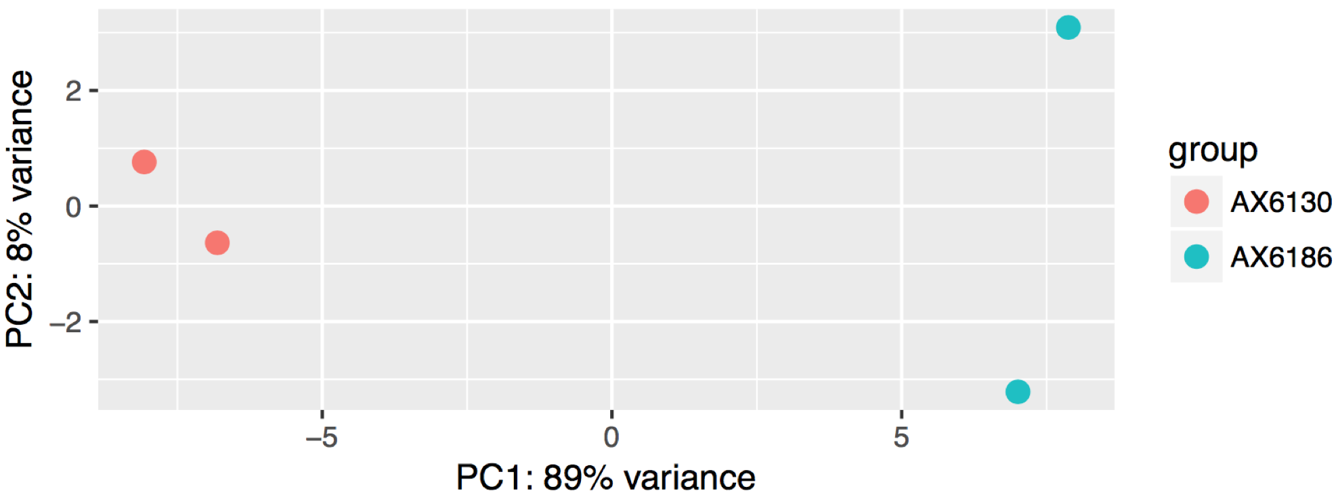

Distance Heatmap and dendrogram:

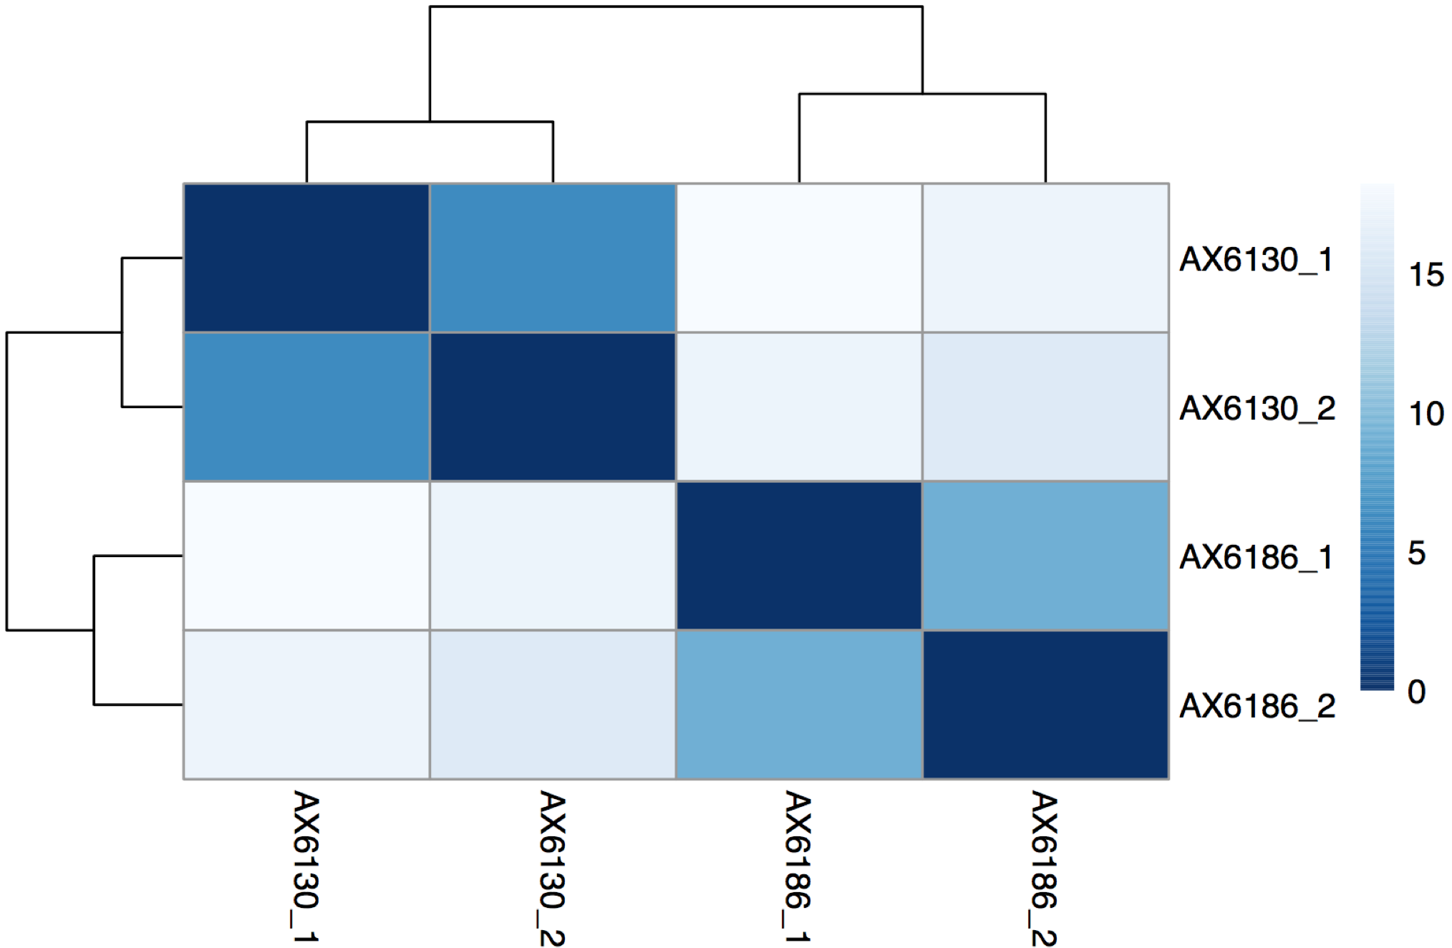

This plots can be found in file XXX_sclust.pdf

This branch also ouputs a series of files:

i) XXX_tpm.txt - normalised read counts for each sample in TPMs (Transcript Per Million)

geneName Brain_I Brain_III SA_I SA_II

ENSMUSG00000000001 105.668741393666 96.1845052420974 96.6721294736383 81.1300724501742

ENSMUSG00000000003 0 0 0 0

ENSMUSG00000000028 9.27276962363166 7.86120331674685 6.8383971237575 10.8227901913994

ENSMUSG00000000031 47.5736143717538 42.7858259493294 99.5364316503101 78.291368530754

ENSMUSG00000000037 2.68646350558992 2.45088437697655 3.62382623242496 2.36372949863057

ENSMUSG00000000049 0.503867319573847 0 0.703801397416308 0.342322751985497

ENSMUSG00000000056 55.0650655823002 56.0200497712557 62.8772648512837 52.4922902804961

ENSMUSG00000000058 27.293946278485 28.5390841778243 31.651206417976 21.4338180309144

ENSMUSG00000000078 88.5291782240821 81.4334381834138 68.4482667602795 35.2922205722676

ii) XXX_DESeq_summary.txt – Overall information of the statistical tests performed and overall result statistics

iii) XXX_DESeq_results_4_peat.txt

test_stat – Wald statistic

p_value – Wald test p-value

q_value – p-value adjusted for multiple testing following the Benjamini-Hochberg method

test_id gene_id gene locus sample_1 sample_2 status value_1 value_2

ENSMUSG00000021848 ENSMUSG00000021848 Otx2 14:48657679_48667644 Deep Superficial OK 706.85 2592.39

ENSMUSG00000058099 ENSMUSG00000058099 Nfam1 15:82997721_83033306 Deep Superficial OK 82.59 326.47

ENSMUSG00000032128 ENSMUSG00000032128 Robo3 9:37415669_37433246 Deep Superficial OK 47.07 384.33

ENSMUSG00000028280 ENSMUSG00000028280 Gabrr1 4:33132521_33163588 Deep Superficial OK 30.93 225.29

ENSMUSG00000045991 ENSMUSG00000045991 Onecut2 18:64340364_64398488 Deep Superficial OK 212.45 43.35

ENSMUSG00000030337 ENSMUSG00000030337 Vamp1 6:125215551_125245964 Deep Superficial OK 4844.90 2091.72

ENSMUSG00000039714 ENSMUSG00000039714 Cplx3 9:57599992_57606281 Deep Superficial OK 32.25 235.98

ENSMUSG00000045518 ENSMUSG00000045518 Onecut3 10:80494835_80517276 Deep Superficial OK 158.69 19.43

ENSMUSG00000022054 ENSMUSG00000022054 Nefm 14:68082590_68124846 Deep Superficial OK 6543.20 1718.54

log2(fold_change) test_stat p_value q_value significant

-1.88 -15.49 4.05E-54 8.54E-50 yes

-1.99 -14.41 4.71E-47 4.97E-43 yes

-3.02 -14.35 1.00E-46 7.04E-43 yes

-2.88 -14.00 1.54E-44 8.10E-41 yes

2.29 13.91 5.14E-44 2.17E-40 yes

1.21 13.69 1.11E-42 3.92E-39 yes

-2.91 -13.46 2.79E-41 8.41E-38 yes

3.01 13.34 1.45E-40 3.81E-37 yes

1.93 12.81 1.40E-37 3.28E-34 yes

iv) XXX_DESeq_norm_read_counts.txt - normalised read counts for each sample using DESeq scaling factors

gene_id SA_I SA_II SA_III DA_I DA_II DA_III

ENSMUSG00000000001 1431.24 1191.69 1525.41 1322.00 1052.32 1215.52

ENSMUSG00000000028 69.90 109.75 77.44 51.10 58.98 75.97

ENSMUSG00000000031 1071.58 836.23 871.96 623.66 272.14 198.56

ENSMUSG00000000037 99.98 64.70 102.90 104.82 94.74 165.75

ENSMUSG00000000049 5.09 2.46 1.06 11.79 0.93 6.91

ENSMUSG00000000056 1371.53 1136.00 1215.66 1145.12 1221.36 1174.08

ENSMUSG00000000058 479.09 321.88 399.92 412.72 277.24 464.45

ENSMUSG00000000078 1364.12 697.82 844.38 860.81 819.19 904.74

ENSMUSG00000000085 1333.57 1505.38 1510.56 1472.68 1515.32 1534.94

6-b) Cufflinks

Similarly to the analysis with DESeq2, PRAGUI generates different plots to assess replicate similarity.

Scatterplot:

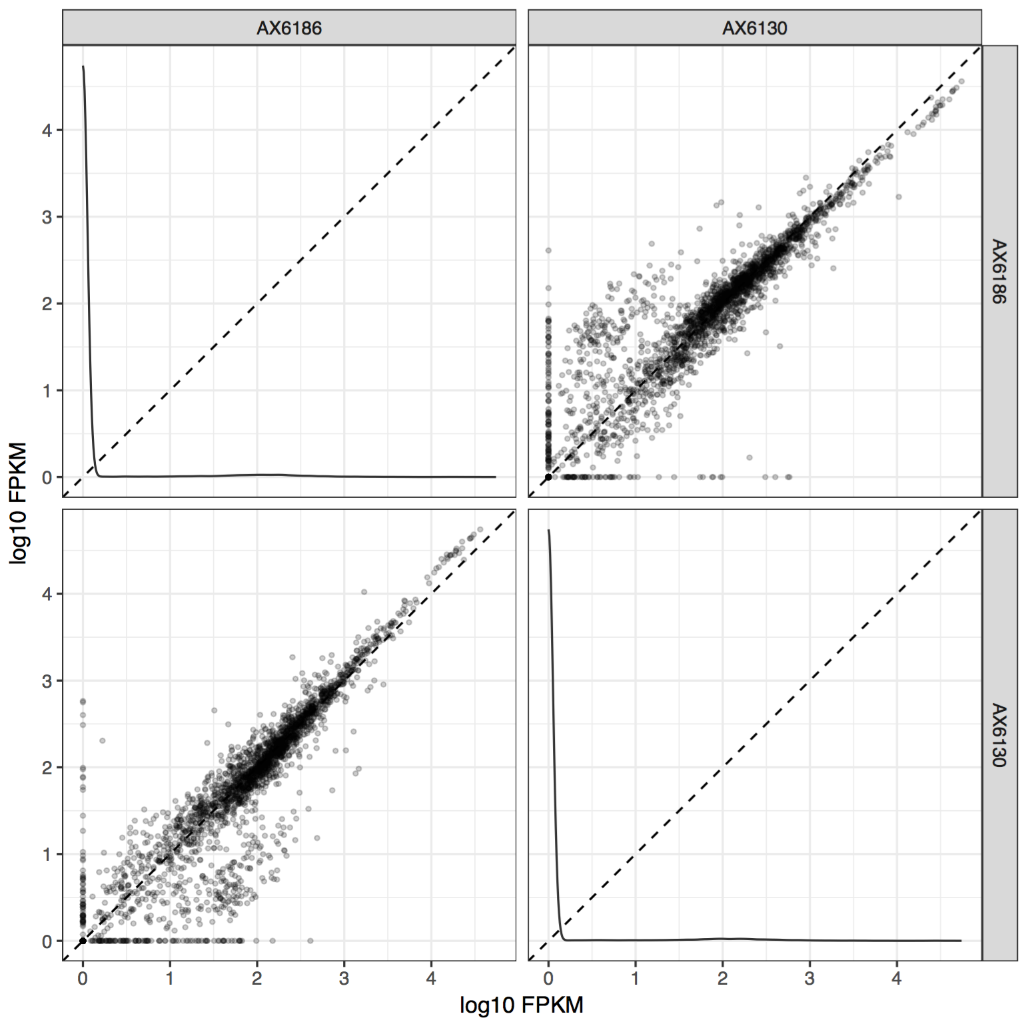

Dendrogram:

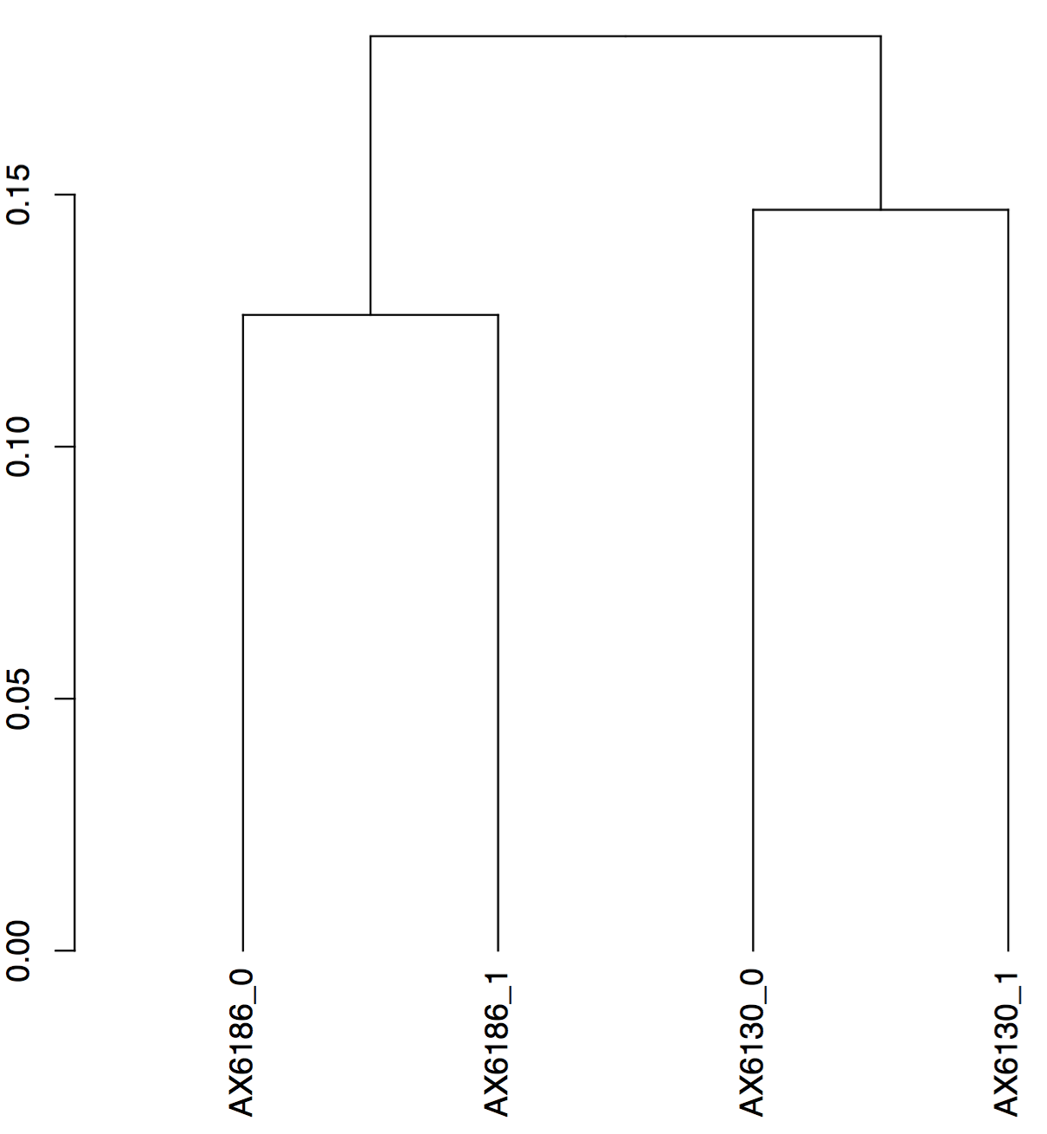

Multi-dimensional scaling (MDS) plot:

(The MDS algorithm performs a non-linear dimensionality reduction such that the between-object distances are preserved as well as possible.)

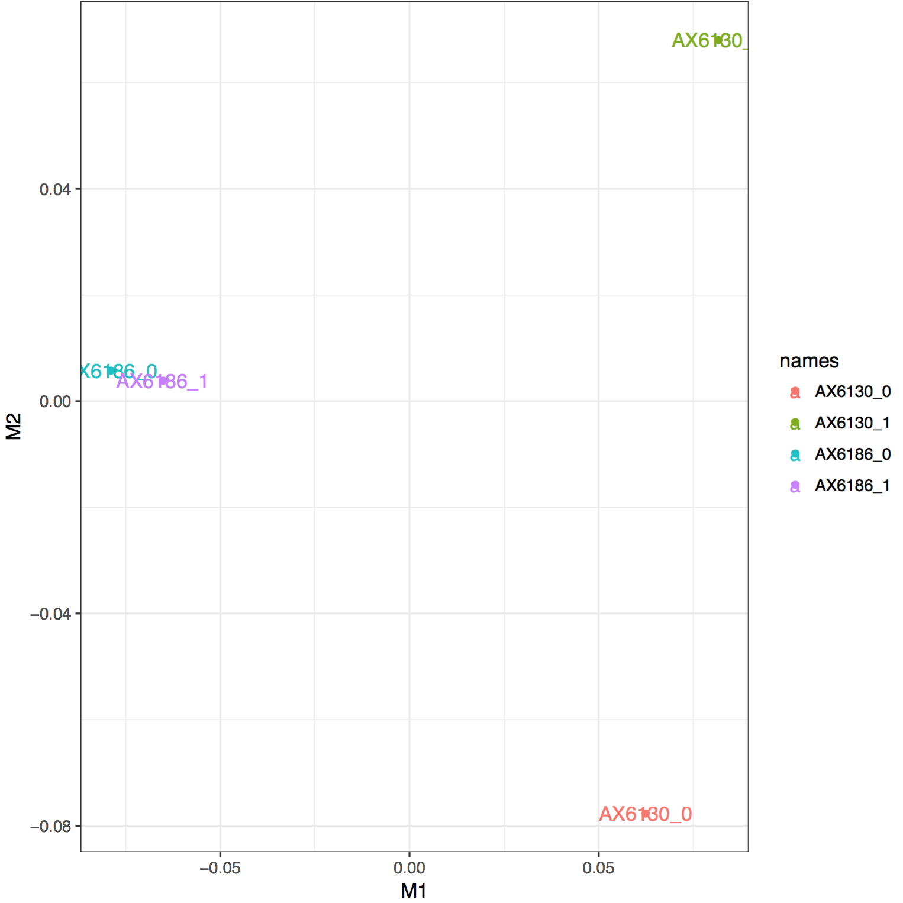

Cufflinks outputs a series of files but the most relevant one for downstream analysis is XXX_exp.diff:

test_id gene_id gene locus sample_1 sample_2 status value_1 value_2 log2(fold_change) test_stat

XLOC_000001 XLOC_000001 - III:16041-17305 AX6186 AX6130 OK 141.692 153.87 0.11895 0.256734

XLOC_000002 XLOC_000002 - III:41089-42019 AX6186 AX6130 OK 1644.62 107.245 -3.93877 -10.9919

XLOC_000003 XLOC_000003 - III:52507-53145 AX6186 AX6130 OK 60.6312 282.131 2.21823 1.74852

XLOC_000004 XLOC_000004 - III:87591-89243 AX6186 AX6130 OK 401.666 416.504 0.0523329 0.148819

XLOC_000005 XLOC_000005 - III:120660-124730 AX6186 AX6130 OK 132.296 254.977 0.946597 2.40236

XLOC_000006 XLOC_000006 - III:124949-126530 AX6186 AX6130 OK 115.5 214.812 0.89518 2.27517

XLOC_000007 XLOC_000007 - III:130955-131752 AX6186 AX6130 OK 205.194 358.335 0.804321 1.8577

XLOC_000008 XLOC_000008 - III:134190-134314 AX6186 AX6130 OK 1185.81 0 -inf -nan

XLOC_000009 XLOC_000009 - III:136160-136309 AX6186 AX6130 OK 2499.8 431.347 -2.53489 -2.18465

p_value q_value significant

0.7171 0.871856 no

5e-05 0.00129273 yes

0.05305 0.268938 no

0.83445 0.9292 no

0.0012 0.0162514 yes

0.00215 0.0262429 yes

0.00965 0.0844449 no

0.00015 0.00304714 yes

0.15475 0.452787 no

q-value – p-value adjusted for multiple testing following the Benjamini-Hochberg method